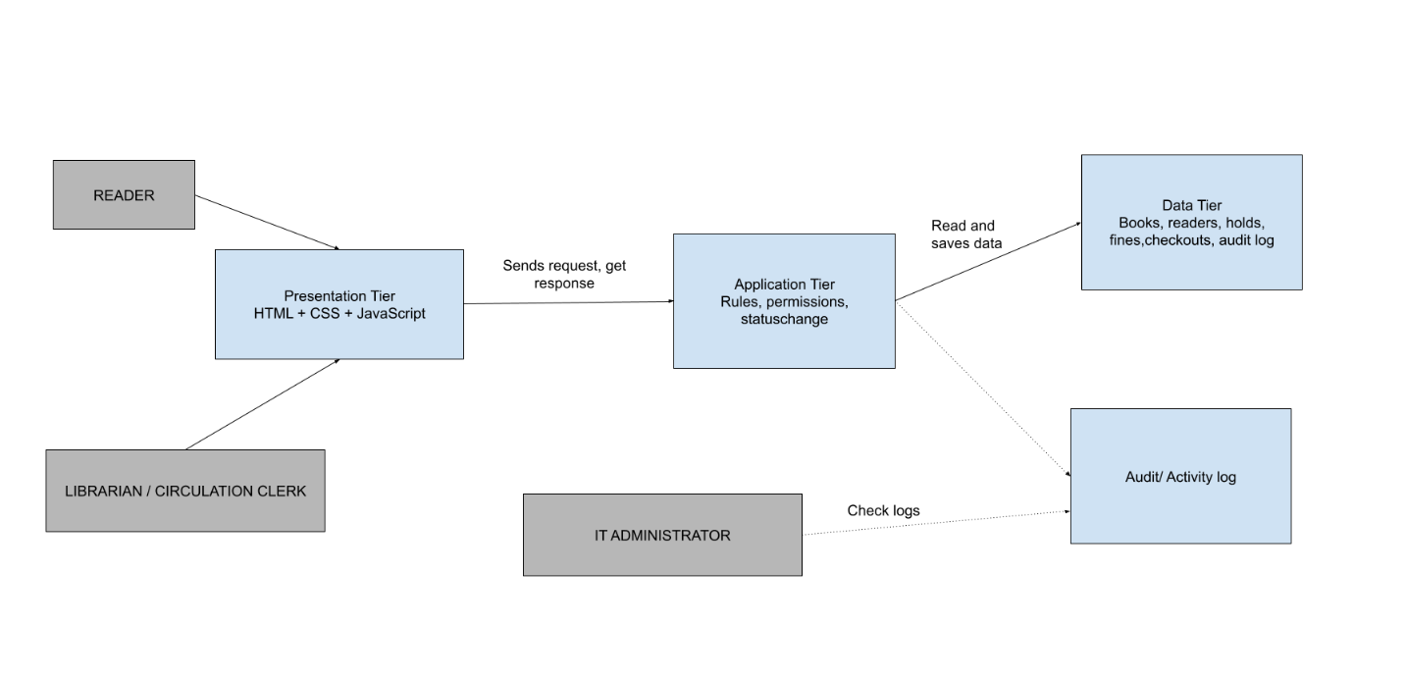
Presentation Tier
Purpose: Interact with customers (READER)
Responsibilities
- Shows the checkout form (Reader ID, barcode/ISBN, checkout date, optional notes)
- Collects what the user types, with clear labels that work with a keyboard (NFR-1)
- Gives quick feedback if a field is empty or wrong
- Shows the due date and a success or rejection message
- Shows the exact reason for a rejection: fines too high, book not available, book on hold, item limit reached, or bad barcode (FR-12, NFR-2)
- Shows the override button only to clerks who are allowed to use it
- Works well on desk computers and staff screens (NFR-4)
Not authoritative for
- Whether a checkout is allowed
- Whether the book is available, on hold, or has fines or limits problems
- How the due date is calculated
- The official status of the book or checkout
- The official checkout ID
- The official time of the transaction
- Saving data permanently
Application Tier
Purpose: make final, trusted decisions about a transaction
Future responsibilities
- Checks that the barcode/ISBN matches a real book (BR-7, FR-3) (Validation)
- Apply business rules
- Blocks checkout reference-only and reserve items
- Calculate due date
- Stop double checkout
- Checks permissions
- Create official transaction ID (checkout ID)
- Checks status changes are allowing
- Records trusted times and audit logs for every checkout
- Read and save data
- Send back feedback
Data Tier
Purpose: keep the official record, allows the transaction to be traceable
Future responsibilities
- Store:
  - Checkout ID (transaction ID)
  - Checkout details ( Reader ID, book ID, checkout date, due date, notes)
  - Official status
  - Reader’s fine balance and number of check-out item
  - Hold records
  - Timestamps
  - Audit history (staff ID and override history)

